ASR: OFI Pick List

**From:** Marcus, Tong   
**Sent:** Wednesday, 14 September, 2016 6:53 PM  
**To:** Chan, Pei-Fong  
**Cc:** Marcus, Tong  
**Subject:** RE: OFI assistance

Hi Pei Fong,

Are you able to assist on the below as customer already kick start this process?

* Change the picklist to 3lots instead on 4lots.
* OFI system to have the logic to scan by the box sequence.
* CTM picklist

-PF: what is the Pick List sorting sequence for CTM ?

Replied: Sort by material number per picklist.

WMS Changes:

1. Pick list split by 3 Lots

* Add Codelkup to setup the # of lots to split in Pick list,
  + ~~Listname = OFIPLLOT’ , Codelkup.code = “ALL” and Short = “# of lots”~~

Setup # of lots per box : codelkup.Short where LISTNAME = 'OFIBU'

(Picklist- auto-print configuration)

Short = # of lot# per box / Split line in Pick List

update CODELKUP set short = 3 from CODELKUP where LISTNAME = 'OFIBU'

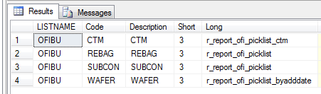

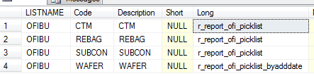

Pick list: SP:

SCH_MICRONOFI_PICKLIST

DW:

r_report_ofi_picklist

r_report_ofi_picklist_byadddate

1. CTM Pick list – sorting by Material code ( ?? )

